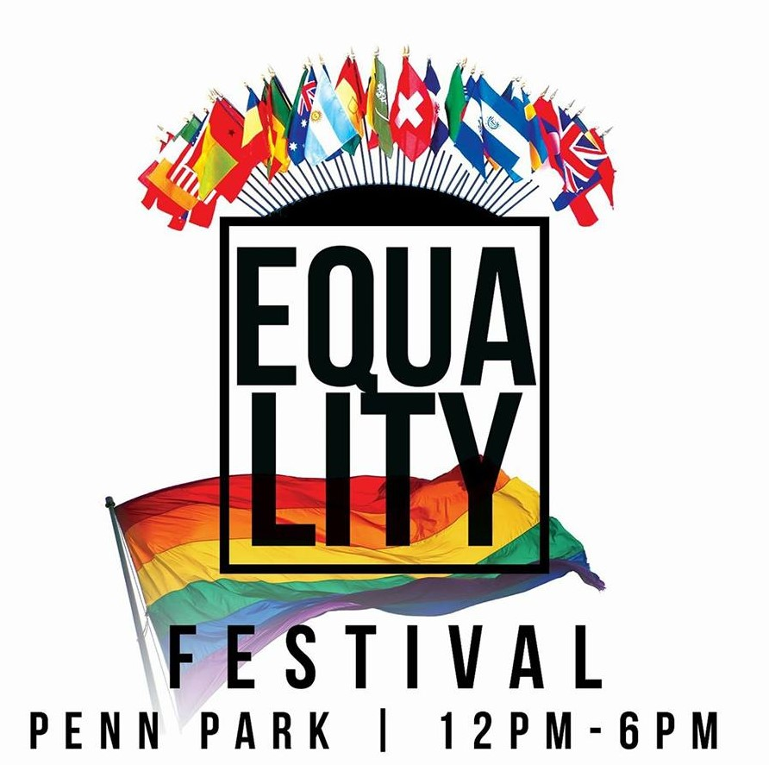
Equality Fest 2019

York, Pennsylvania

IDEAS Center 15 N Cherry Ln York, PA 17401

www.equalityfestyork.com

Equality Fest Vendor Agreement

Event Date: Sunday, August 4, 2019
Event Location: Penn Park (143 W College Ave, York, PA 1741)
Event Time: 12:00pm - 6:00pm
Set Up Time: 10:00am – 11:00am
Break Down Time: 6:00pm – 7:00pm
Cost: $25.00 for Information/Nonprofit/Faith Community/Artists
$50.00 for Retail/Sales (No Food)
$75.00 for Food Sales
12’ x 12’ space (MUST PROVIDE OWN TABLE/TENT/CHAIRS)

Vendor Name:
Vendor Website (if applicable):
Mailing Address:
Contact Person:
Contact Phone Cell Phone Number
Contact E-mail:
Vendor Type (circle all that apply): Information Nonprofit Products/Retail Artist/Pop-Up Gallery
Faith Group Food

Vendors will be acknowledged on the Equality Fest Facebook page and on the Equality Fest website.

Payment is due at time of agreement. Equality Fest is a “rain or shine” event. No refunds are offered in the event of vendor cancellation. Payment must be paid via paypal to equalityfestyork@gmail.com or check/money order made payable to EQUALITY FEST with “vendor fee” in the memo. E-mail completed application or mail completed application and payment. Completed application with payment must be received NO LATER THAN July 1st to:

Equality Fest in the IDEAS Center
15 N Cherry Ln
York, PA 17401
-or-
equalityfestyork@gmail.com

